|  |
| --- |
| Group 2 |
| CLCM3998  Statement of Work |
| [Videoster] |
|  |
| Akilandeshwari Srinivasan  Ambedkar Rani Subbiah  Ashutosh Chaudhary  Taniya Kamboj  Zeren Ju |
|  |

|  |
| --- |
|  |

Table of Contents

1. Document Version 3

2. Team Contact Information 3

3. Description 3

4. Proposed Solution 3

5. Stakeholders 3

6. Proposed Technology 3

7. Assumptions 3

7.1. Non-Technical Assumptions 4

7.2. Technical Assumptions 4

8. Deliverables 4

9. Requirements 4

10. Lower Priority Features 4

11. Out of Scope 5

12. Existing System 5

13. Diagrams 5

13.1. Client Diagrams 5

13.2. Team Diagrams 5

14. High-Level Schedule 5

15. High-Level Work Breakdown Structure (WBS) 5

16. Risks and Issues 6

## Document Version

|  |  |  |  |
| --- | --- | --- | --- |
| **Version** | **Description** | **Date** | **Author(s)** |
| **1** | Created | 03/02/2024 | Ambedkar Rani Subbiah |
| **2** | Created | 02/03/2024 | Taniya Kamboj |
| **3** | Created | 24/03/2024 | Akilandeshwari Srinivasan |
| **4** | Created | 14/04/2024 | Ashutosh Chaudhary |

## Team Contact Information

Akilandeshwari Srinivasan – [a.srinivasan036@mybvc.ca](mailto:a.srinivasan036@mybvc.ca)

Ambedkar Rani Subbiah – [a.subbiah771@mybvc.ca](mailto:a.subbiah771@mybvc.ca)

Ashutosh Chaudhary – [a.chaudhary957@mybvc.ca](mailto:a.chaudhary957@mybvc.ca)

Taniya Kamboj – [t.kamboj808@mybvc.ca](mailto:t.kamboj808@mybvc.ca)

Zeren Ju – [z.ju688@mybvc.ca](mailto:z.ju688@mybvc.ca)

Ife Agboola (Supervisor) - [iagboola@bowvalleycollege.ca](mailto:iagboola@bowvalleycollege.ca)

## Description

The project aims to elevate the Videoster platform by transitioning it into a mobile application using the AppMySite plugin. The client recognizes the growing trend of mobile-centric content consumption and views this transformation as an opportunity to enhance user engagement and accessibility. The key business problem being addressed is the need to adapt to evolving user preferences, providing a seamless and feature-rich mobile experience for Videoster users. By leveraging AppMySite's capabilities, the client aims to capitalize on the opportunity to reach a broader audience, improve user satisfaction, and stay competitive in the dynamic digital landscape.

## Proposed Solution

Our team will deliver a fully functional and visually appealing mobile application for Videoster, seamlessly integrated using the AppMySite plugin. The final product will offer a user-centric design with intuitive navigation, featuring essential functionalities such as video playback, user profiles, and content discovery. By leveraging AppMySite's capabilities, we aim to create a feature-rich application that not only addresses the current business problem of evolving user preferences but also takes advantage of the opportunity to expand the platform's reach, improve user satisfaction, and stay ahead in the competitive digital landscape.

## Stakeholders

Rundong Li – [ceo@videoster.com](mailto:ceo@videoster.com)

## Proposed Technology

The core technology driving the transformation of the Videoster website into a mobile app is the AppMySite plugin. This tool streamlines the app development process and facilitates seamless integration with existing WordPress content.

Our team plans to utilize Trello, a project management tool, to keep track of lists of tasks completed, ongoing and to do. Trello will enhance our project organization and collaboration efforts, ensuring efficient progress tracking and task management throughout the development lifecycle.

## Assumptions

No Assumptions

## Deliverables

|  |  |
| --- | --- |
| **Deliverable** | **Description** |
| AppMySite Plugin | The plugin was used to convert the website to mobile app |
| Documentation | Final document which is related to how we have done so far in technical terms |

## Requirements

**User Roles and Authentication:**

* Define user roles: Customer, Videographer.
* Implement secure authentication and authorization mechanisms.

**Customer Features:**

* User registration and profile creation.
* Browse/search functionality to find local videographers.
* View videographer profiles, portfolios, and ratings.
* Post tasks with detailed project requirements.
* Real-time chat functionality to communicate with videographers.
* Project management tools (pre-production, production, post-production phases).
* Integration with payment gateways for secure transactions.
* Review and rating system for completed projects.

**Videographer Features:**

* User registration and profile creation.
* Location-based services to list themselves in their respective areas.
* Portfolio creation and showcase.
* Create and manage services/gigs.
* Participate in bidding on client-published projects.
* Real-time chat functionality with customers.
* Project management tools.
* Integration with payment gateways for secure transactions.
* Review and rating system for completed projects.

**Auto-Matching Functionality:**

* Algorithm for matching local videographers with customer projects.
* Consideration of parameters like location, availability, skills, and ratings.

**Notifications:**

* Push notifications for new tasks, messages, project updates, etc.
* Email notifications for important updates.

**Admin Panel:**

* Dashboard for admin to oversee platform activities.
* User management and access control.
* Content management for reported content or disputes.
* Analytics tools for monitoring platform usage.

**Security:**

* Encryption of sensitive data.
* Secure authentication and authorization mechanisms.
* Regular security audits.

**Payment Integration:**

* Integration with a reliable payment gateway.
* Secure handling of financial transactions.

**Technology Stack:**

* Specify the preferred technology stack (e.g., frontend framework, backend language, database).
* Consider scalability and future expansion.

**Data Storage and Backup:**

* Specify data storage requirements.
* Implement regular data backups.

**Testing:**

* Define a comprehensive testing strategy.
* Include unit testing, integration testing, and user acceptance testing.

**Compliance and Legal Considerations:**

* Ensure compliance with data protection regulations.
* Clearly define terms of service and privacy policy.

**Scalability and Future Enhancements:**

* Plan for scalability as the user base grows.
* Leave room for future feature enhancements.

**Documentation:**

* Provide comprehensive documentation for developers and future maintenance.

**Timeline and Milestones:**

* Define project timelines and milestones.
* Include regular check-ins and feedback sessions.

**Cross-Platform Development and Ionic Integration:**

* Specify that the mobile app should be developed as a cross-platform application for compatibility with both iOS and Android devices.
* Consider using webview mobile app platforms, such as Ionic, to leverage the existing web application codebase for mobile development.
* Emphasize the importance of providing a seamless user experience on mobile devices.
* Optimize the app's user interface for mobile devices.
* Highlight the need for a location-sharing feature, especially in version 2 of the application.
* Specify that videographers should use mobile devices for the best user experience and to enable features such as sharing their location when in transit.
* Provide details on the choice of webview mobile app platforms, such as Ionic, including any specific version requirements or considerations.
* Emphasize the cost-saving benefits associated with using webview mobile app platforms.
* Discuss how the chosen webview mobile app platform (Ionic) supports scalability for future enhancements and features.
* Specify that the mobile app should be optimized for performance on both iOS and Android devices when using the webview mobile app platform.
* Include testing procedures to ensure cross-platform compatibility, considering variations in device types, screen sizes, and operating systems.
* Emphasize that the use of webview mobile app platforms will significantly reduce the overall mobile application development cost.
* Highlight the benefits of reusing the existing web application codebase to minimize development efforts.

## Lower Priority Features

Not Applicable

## Out of Scope

Not able to modify Home Screen as per client’s expectations using AppMySite plugin.

## Existing System

The client currently operates a website to provide their services. The website serves as the primary platform for users to access information, make enquiries, and engage with the client’s offerings. It includes features such as service listing, contact forms, and informational pages.

## Diagrams

## Client Diagrams

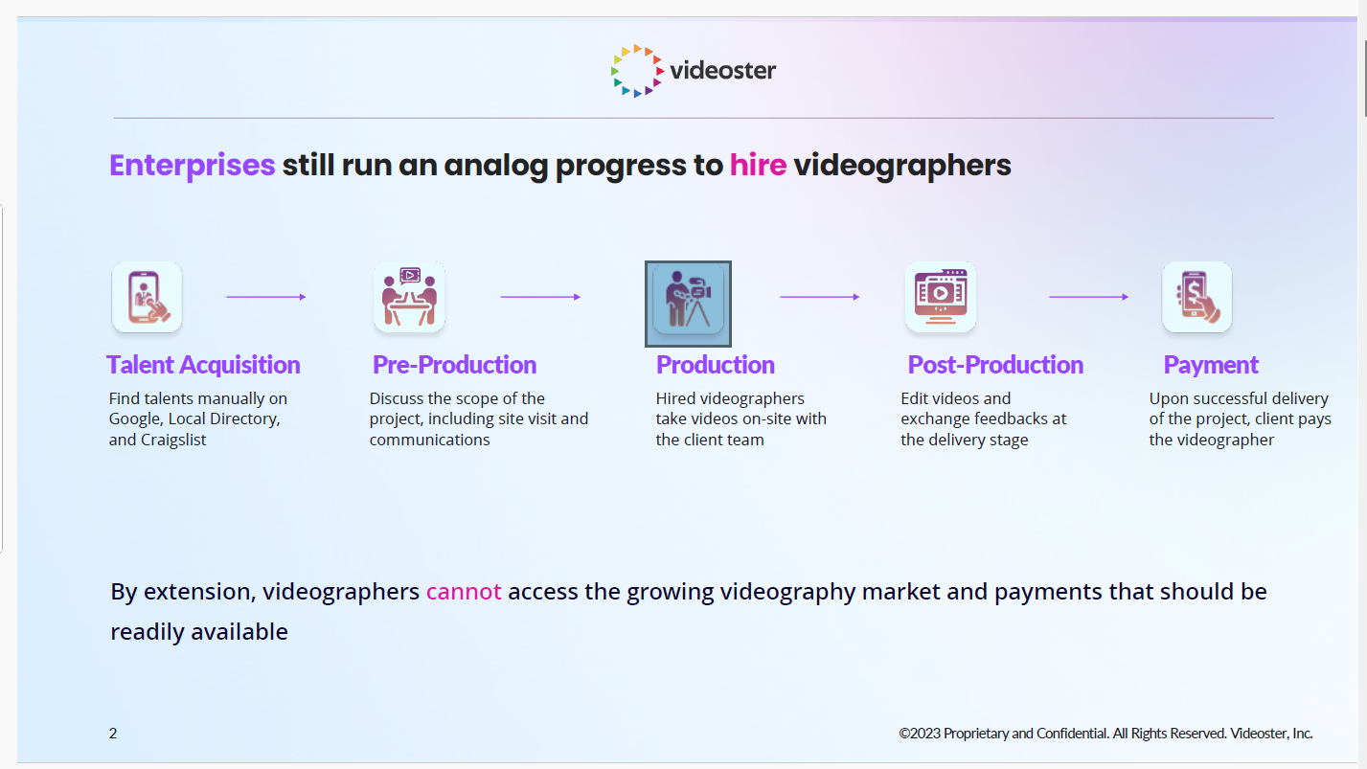

## Team Diagrams

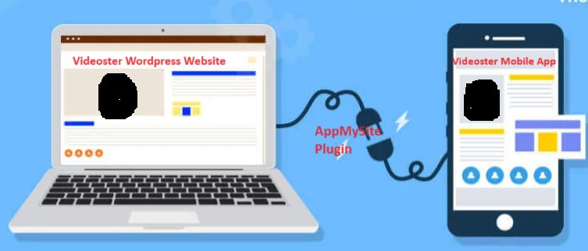

## High-Level Schedule

We have created the below timeline for the project implementation:

1**. Initial Setup and Configuration:**

Estimated 1-2 weeks (may vary based on website complexity)

**2. Design Customization:**

Estimated 2-3 weeks (designing layout, color schemes, ensuring responsive design)

**3. Development and Testing:**

Estimated 4-6 weeks (implementing features, testing on different devices, addressing any issues)

**4. Finalization and App Submission:**

Estimated 1-2 weeks (making adjustments, optimizing for app stores, submission for review)

## High-Level Work Breakdown Structure (WBS)

|  |  |  |
| --- | --- | --- |
| **Owner** | **Description** | **Completion Date** |
| Akilandeshwari Srinivasan | Cloud Migration Planning and final documentation | 14-Apr-2024 |
| Ambedkar Rani Subbiah | Functional Testing and Preparing Test cases | 14-Apr-2024 |
| Ashutosh Chaudhary | Cloud Migration Planning and final documentation | 14-Apr-2024 |
| Taniya Kamboj | Cloud Migration Planning and final documentation | 14-Apr-2024 |
| Zeren Ju | Cloud Migration Planning and final documentation | 14-Apr-2024 |

## Risks and Issues

|  |  |  |
| --- | --- | --- |
| **Risk or Issue Description** | **Potential Impact** | **Mitigation/Resolution Steps** |
| Project objectives and customer requirements are unclear. | Influence the development of project scope and related solutions. | 1. Internal discussion.  2. video meeting with client. get more details of his requirements, share our solution to him and confirm with him. |
| There are differences in the implementation of technical solutions. | Affect project process. | 1. This project will focus on application development, not web development. Reach agreement within our team. |
| Obtain customer's existing website source code in a timely. | Impact project startup. | 1. sign Non-Disclosure Agreement (NDA) document with client.  2. make a meeting with client and show what kinds of documents we need from his side. |
| No experience on application development. | This will make it impossible for us to complete our project. | 1. all the team members need to learn knowledge about Wordpress development and Application development. |
| Project progress is not synchronized with client in time. | Affect customer satisfaction. | 1. Made project roadmap and shared it to client. Let client know what our plan is.  2. Hold regular online meetings. Collect the latest requirements and keep abreast of the latest developments. |
| How to integrate chat system in this application? | Impact project requirements implementation. | 1. use 3rd part chatbot.  2. integrate chat API into our application. |
| Original requirement changed | The project completion time point is affected. | 1. analysis of these new requirements.  2. show the new requirements go against the purpose of application development.  3. convince client to keep the original plan unchanged. |

## Ethical Impact

Not Applicable